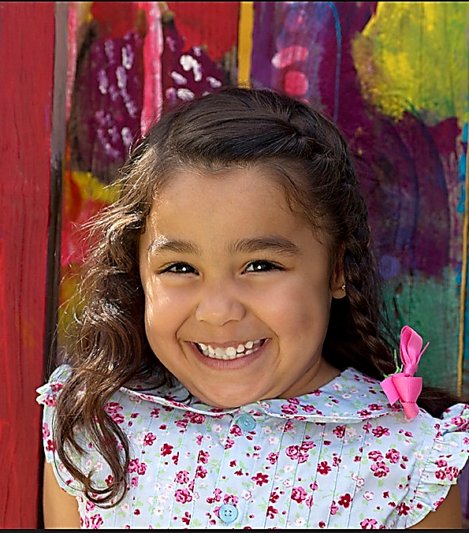

Licensing

Phone: (440) 354-3000

Website: www.stpaulspainesville.com

**St. Paul’s Lutheran Preschool**

Our Curriculum

Daily schedule will include activities in the following areas:

* Spiritual/social/emotional living
* Communicative arts (language development)
* Expressive arts (creative development)
* Wellness (physical development)
* Discovery about the world (cognitive development)

The teachers have access to the State of Ohio Early Learning Standards and will plan their activites within the framework of these guildelines. Classroom lesson plans are posted for parents to view each day.

Our Goal

Our program is based on the premise that children learn best through play-based, hands-on experiences in an environment where individual needs of each child are taken into consideration. Therefore, although specific objectives differ for each child, our preschool program provides the following for all children:

* Experiences to help children learn to know and learn about a loving God
* Opportunities for children to grow in self-confidence and an appreciation for others
* An environment to stimulate the learning of young children
* Readiness to enter kindergarden

.

“We love St.Paul’s and would recommend it to ANYONE! In fact, I often do. I am impressed by how well my child has done in her class."

Quote from our Parent Survey

St. Paul’s Lutheran Preschool is a non-profit organization licensed through the Ohio Department of Job and Family Services.

We are accredited by the National Lutheran Schools Accreditation

Have questions or like to schedule a visit?

Please contact Amy Marizek at (440) 354-3000 or email us at **preschool@splcpainesville.org**

250 Bowhall Rd.

Painesville, OH 44077

Fax: (440) 354-7085

Congue nihil imperdiet doming id quod mazim placerat facer minim veni am ut wisi enim ad minimeniam, quis erat nostr uexe

rci tation ullamcorper nostru exerci tation ullam corper et iusto odio dig nissim qui blandit praesent lupta. Tummer delenit

augue duis dolore te feugait nulla facilisi. Con erattis sectetuer adip iscing elit, sed erat diam nonummy nibh magna erat.

Discover the Difference

2019-2020

**St. Paul’s Lutheran Preschool**

Classes Offered

***Early Learning Classes 3 & 4 Years Old***

12 Students per class  *\*Child must be 3yr by Sept 15*

Mon & Wed Tue & Thur

9:00 -11:30 AM or 9:00 - 11:30 AM

12:30 - 3:00 PM

________________________________

***Friday Extension for 3’s*** *Child must be enrolled in a 3’s class from above

Friday

9:00 - 11:30 AM

________________________________

***Preschool Classes 4 & 5 Years Old***

14 Students per class *\*Child must be 4yr by Sept 15*

Mon, Wed & Fri Tue & Thur

9:00 -11:30 AM or 9:00 – 12:00 PM

12:30 - 3:00 PM

_________________________________

***Pre-K Classes 4 & 5 Years Old***

16 Students per class *\*Child must be 4yr by Sept 15*

Mon - Thur

9:00 -11:30 AM or

12:30 - 3:00 PM

Enrollment Policy

For enrollment the following criteria need to be in place:

* The child must be age eligible
* The child must be toilet trained
* Registration fee paid
* Completed registration form submitted

Tuition

**Early Learning Classes 3 & 4 Years Old**

Mon & Wed - $105/month Tue & Thur - $105/month

_________________________________

**Friday Extension for 3’s**

M/W/F - $130/month T/TH/F - $130/month

_________________________________

**Preschool Classes 4 & 5 Years Old**

M/W/F - $130/month Tue & Thur - $115/month

_________________________________

**Pre-K Classes 4 & 5 Years Old**

Mon through Thur - $150/month

(Tuition is due each month from September to May, for a total of 9 payments)

*Yearly Materials Fee of $50 for each student

Staff

Our staff members meet the academic qualifications for their positions, have required State training, attend conferences and workshops to futher their professional growth and possess a love and interest in children and their families.

Mission Statement

It is in grateful response to God’s love for us in Christ Jesus, that St. Paul’s Lutheran Preschool assist families in carrying out God’s command to educate His children and prepare them for a Christ-centered life of learning and service.

St. Paul’s Lutheran Preschool **Registration Form**

Please mark your class choice as 1st and 2nd choice

**T/TH M/W F/Extension**

___3’s AM ___3’s AM ___3’s AM

___3’s PM

**T/TH M/W/F M/T/W/TH**

___4’s AM ___4’s AM ___Pre-K AM

___4’s PM ___Pre-K PM

Child’s Name: _________________________________

Gender: **M** / **F** (Circle One)

Date of Birth: __________________

Mother’s Name: _______________________________

Mother’s Cell: _________________

Father’s Name: _______________________________

Father’s Cell: __________________

Home Phone: __________________

Address:__________________________________

_________________________________________

City: ___________________________

Zip: ____________________________

Church Affiliation: ______________________________

Parent’s Signature:

_____________________________________________

Registration

Registration is first-come-first-serve basis. A $60 non-refundable fee per child must be submitted with their registration form. If interested, please submit the attached registration form and registation fees to the school.

St. Paul’s Lutheran Schools welcome students of any race, color, national or ethnic origin, sex, religion, privileges, programs, and any activities generally accorded or made available to the students at the school.