 

St. Paul’s Lutheran Preschool

May Newsletter

Preschool Mission Statement

In grateful response to God’s love for us in Christ Jesus, it is the mission of St. Paul’s Lutheran Preschool to assist families in carrying out God’s command to educate His children and prepare them for a Christ-centered life of learning and service.

A Message from Pastor Sundbom

**Special Events**

**April**

**22 Captains Game**

**19-23 Easter Vacation**

**26 Mrs. Davis’s Field Trip for 4s Classes**

**May**

**2 Mom and Me at 6:30**

**6 & 7 Chapel**

**8 Mrs. Johnson’s Field Trip for 3s Classes, Mrs. Mihalik’s Field Trip for Pre-K AM ’s**

**9 Mrs. Marizek’s Field Trip for PM Pre-K**

**13 & 14 Morley Visit**

**21 Closing Program and Last Day of Class for T/TH and Pre-K Classes**

**22 Closing Program and Last Day of Class for M/W and M/W/F Classes**

The topic of teaching the Christian faith has been debated in the Church for Centuries. Throughout her history, the Church has had different ways of looking at & dealing with the topic. In the 14th & 15th Centuries for example, it was widely accepted that the Priests & Bishops were the only ones capable of teaching the faith. They were the ones who were able to read and understand Latin, the language of education in the day. They were the ones the people went to for understanding what the Scriptures said. They were the ones who could read the Bible.

Fast forward a little to the time of Marin Luther. History brought one major invention that was truly revolutionary: the Printing Press. It gave the ability to print in mass quantities, making reading materials more widely available. Luther then set out to use this technology to print the Bible in a more common, spoken language: German. No longer would people be unable to read the Bible and rely solely on Priests & Bishops to tell them what the Bible said. They could now read it on their own. Luther also put together 2 wonderful teaching tools. As he went around to different congregations, he saw how little, if anything, the people of the congregations, or even the Pastor, knew about the Christian faith. He scolded the Bishops & Pastors for being so lax on their personal learning and teaching of the Christian faith. In 1529, Luther published the Large Catechism and the Small Catechism. The Church Office has copies of the Small Catechism available if you would like to look at it.

Today, there is a wealth of information and methods for teaching the Christian faith. Whose responsibility is it to teach the Christian faith? Parents? The Church? I believe it is a team effort, parents & Church together. I like to picture the process as a circle that begins in the congregation. As families gather for worship, they hear and read the Scriptures. They hear the Scriptures proclaimed & explained. The family then is able to take what they have seen & heard in the worship & education hours and talk about them in the home. The family then can develop their own way of reading & talking about Scripture the rest of the week. By Sunday, they are ready to return to the worship and education hours to hear more of the Scriptures proclaimed and explained. The circle continues Sunday after Sunday.

To successfully teach the Christian faith, family and congregation need to be in partnership. I want to encourage families, disciples of all ages, to take advantage of the worship and education times of your home congregation. If you have no home congregation, then we invite you to join our worship and education hours. The School of Faith has no graduates, and her students learn at all ages and stages.

Worship schedule at St. Paul’s [through May 19]

Worship 6:00 p.m. Saturday 8:15 & 10:45 a.m. Sunday

Sunday School/Adult Bible Study 9:30 a.m. Sunday

[From May 26 – Sept 1]

Worship 6:00 p.m. Saturday 9:30 a.m. Sunday

Adult Bible Study 8:30 a.m. Sunday



 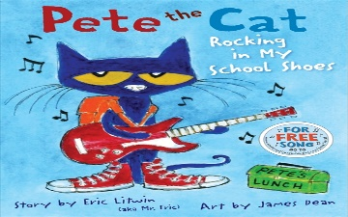 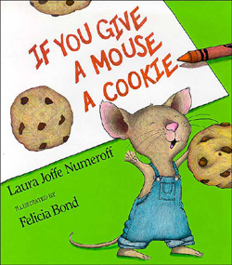 

**Mom & Me**

Share A Book With Me!

May 2nd at 6:30

We look forward to seeing you Thursday night!

`

Parent Evaluation Forms

Parent Evaluation Forms have been sent home, if you need another copy please stop by the preschool office. Thank you for providing your input into our program. We value your comments as we strive to improve each year. If you have any questions please see Mrs. Marizek.

MC900105218[1]MC900105218[1]

Preschool Library

The children will not have library for the entire month of May. Please return the last library book by May 13th so that the teachers can collect all of the books and close up the library for the school year. We hope that you have enjoyed reading with your children.

 



Closing Program and

Portfolio Day

The Closing Program and Portfolio Day will be on the last days of school. The children will be singing and then families are invited back to the classrooms to view the portfolios. The program will start as soon as everyone arrives, so please sign your children into their classes and find a seat in the church. The program will be about 30 minutes long and then everyone is free to view portfolios and visit with the preschool teachers, staff and other preschool families.

**May 21 at 9:00**

Closing Program/Last Day

Mrs. Johnson’s T/TH Class

Mrs. Davis’s T/TH Class

Mrs. Mihalik’s Pre-K Class

and Mrs. Marizek’s Pre-K Class

**May 22 at 9:00**

Closing Program/Last Day

Mrs. Johnson’s M/W Class

Mrs. Davis’s M/W/FClass

**This will not be a full class day. We hope you have a fun and safe summer.**

Scholastic Book Orders

The last order forms have been sent home. If you are interested in ordering any of the items, please complete the order form and write one check to SCHOLASTIC. The preschool will earn points from every purchase. Points can then be turned in for classroom materials. This program is a great way to add to your home library and enjoy good books with your children. If you have any questions please ask Mrs. Marizek. Return orders to the Scholastic folder in the preschool office. The books will be placed in your child's mailbox about two weeks after the deadline date. Current orders are due May 6 & 7.

Thank you for all of your orders this year!

**Online Ordering Information  
Web address: scholastic.com/bookclubs  
Class Activation Code: HDQZD**18.

Morley Library

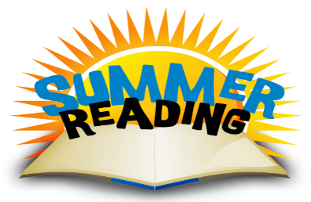

All classes will be participating in the last Morley Library visit for the year. We thank them for all of the fun stories, songs, and flannel board stories. We hope you will stop by the library and enjoy the summer reading program.



All of us at St. Paul’s Preschool would like to thank you for sharing your children with us. It has been a joy to watch them grow. For those of you that are returning next year, we’ll see you soon. For those that will be moving on, you will be missed. Have a safe and enjoyable summer.

God Blessings,

St. Paul’s Preschool